通俗的解释：处理带约束的二次规划，通过迭代原始空间变量（x，z）对偶空间变量（y）拉格朗日乘子得到最优解，z是增加的变量来处理约束，有一个Ax=z l<=z <=u 原始空间迭代的时候必须满足x，y在search的时候 是能找到Ax_=z_, 通过理论先验可以提现发现我们肯定找不到这两组x{k} 和 z{k}, 所以就提前结束优化了，primal-infeasible，下面是比较简单的理论解释。

证明思路：通过达到最有条件反推x{k} 和 z{k} 不可能达到最有条件（借助dual variable，同样有个条件判断dual_infeasible）.

Conclusion：primal-infeasible detection：

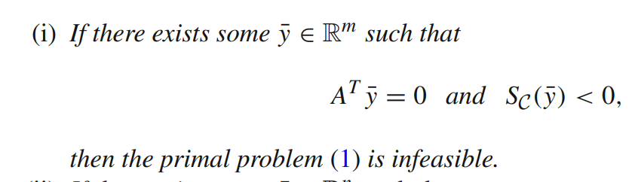

Here y represents the dual-varible，first equation means exist y in null space of A^{\T},the second inequality means sup<y,z> < 0 here means the inner product of vector y and z always less than 0(we need to find a z in our feasible region C),

this means this means there always exists a hyperplane that separates the sets {Ax : x ∈ Rn} and C strongly, now let’s see why this means the primal-problem is infeasible.

We turn to see the optimality for our problem following: the conclusion in the first part means the first condition never satisfied.

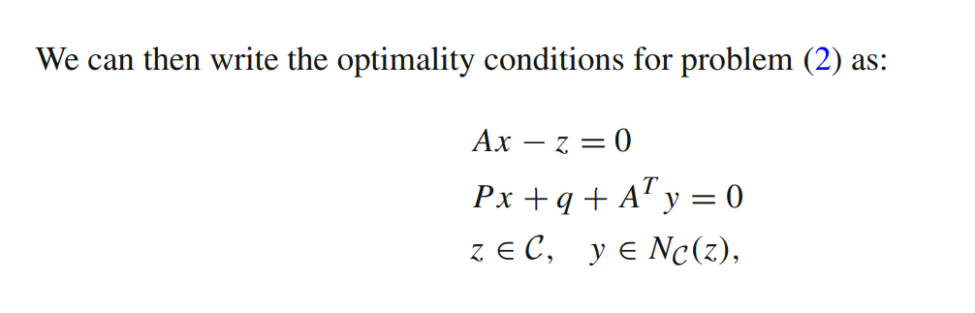

Finally,let’s see the specific osqp solver how works :

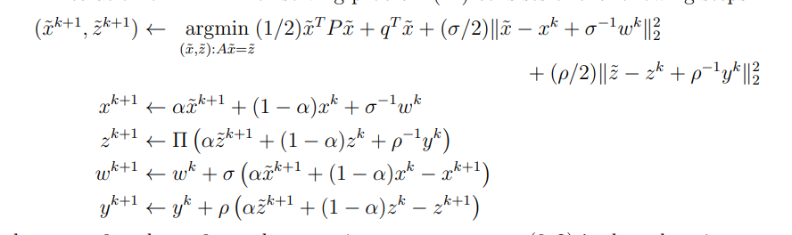

Go to final results: in the solver, the way to check primal infeasible: compute A^{T}*\delta y=0, Sc(\delta y)<0 / Ax^{k+1}-z^{k} this variable can been fectched by osqp api.

我推测的数值精度丢失在这里解第一个线性方程组丢失，这是另外一个solver。

